TO: Scott Hazlegrove, Washington Beer & Wine Distributors Association
FROM: Anna Boone
DATE: March 5, 2015
RE: 2015 Litter Survey in Olympia AIA

Introduction
Gallatin Public Affairs conducted a study of litter, specifically of alcohol containers, within the downtown Olympia Alcohol Impact Area. The methodology for the litter survey was designed to replicate the City of Olympia’s 2013 Beer and Wine Container Survey. The mandatory Alcohol Impact Area went into effect in Olympia in December 2013.
Methodology
Surveys were conducted 1-2 times a week over the course of six weeks within the existing AIA boundaries and following the survey routes taken in the City of Olympia’s 2013 survey, as demonstrated in maps included in that study (Figures 1 and 2). Surveyors searched for evidence of drinking in public in the form of alcohol containers (beer, wine and hard alcohol cans and bottles) littered in streets, alleyways, bushes and parks. The survey was conducted between January 8, 2015 and February 10, 2015. Each data collection period took approximately 3-4 hours.
When a used alcohol container was located, the surveyor would photograph the litter and log the date, time, location, brand and size of container. Once photographed, the cans were disposed of in order to prevent duplicate instances in the dataset. When containers could not be disposed of (out of reach of surveyor), incidences were cross-referenced with previous data to ensure each data set was singular in occurrence.

Figure 1: Data collection route Figure 2: Data collection route
(2015 study) (2013 City of Olympia study)
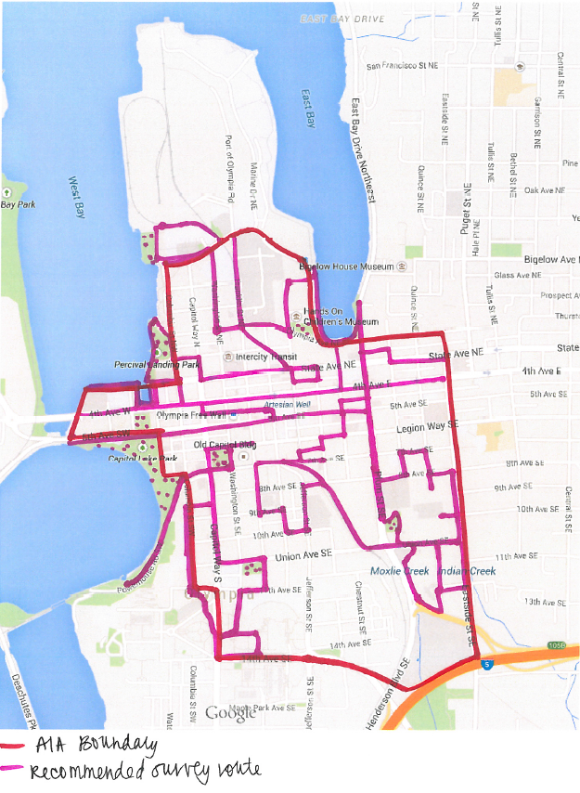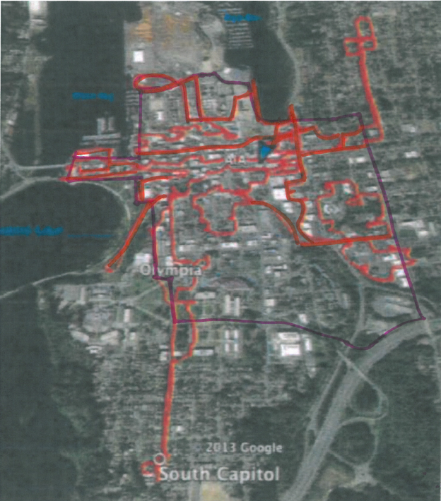

Results/Analysis
A total of 62 unique products were found in the survey. 55 of the products were beer/wine and seven were hard alcohol. (This compares to 114 unique products found, 86 of which were beer/wine and 28 hard alcohol, in the 2013 study.) A total of 227 beer, wine and liquor containers were located in the survey, as compared to 1,020 located in the 2013 study.
WAC 314-12-215 (3d) states “[r]estricted beer and wine products must have minimum alcohol content of five and seven-tenths percent by volume and twelve percent by volume, respectively.” Using 5.7% alcohol by volume (ABV) for beer and 12% ABV for wine as a cutoff, products were split into three categories: Low-Alcohol (Beer < 5.7% ABV; Wine < 12% ABV), High-Alcohol (Beer ≥ 5.7% ABV; Wine ≥ 12% ABV) and Hard Alcohol.
Of the 55 beer/wine products, there were 21 high ABV and 34 low ABV beer/wine products. The City of Olympia’s 2013 study revealed similar results with 36 high ABV and 50 low ABV beer/wine products found. Included in the found high ABV containers were 6 products banned in Olympia’s creation of the Alcohol Impact Area in 2013.

Unlike the 2013 study, which found that high ABV containers made up 68.04% of found containers (with low ABV containers and hard alcohol containers making up 27.65% and 4.31% respectively), our study revealed that low ABV containers made up 67.40% of found containers, while high ABV containers accounted for 27.75% of containers and hard alcohol containers at 4.85%.
The percentage of hard alcohol containers remained relatively consistent, while the percentage of found high and low ABV containers switched between the 2013 and 2015 studies, during which the Alcohol Impact Area was established.
We believe the Gallatin survey resulted in fewer total litter samples due to two main reasons. The City of Olympia survey was conducted in the peak of the summer for a longer duration, while the Gallatin survey was conducted in the winter during a seasonally rainy period. The City of Olympia’s “litter” survey also went well beyond what would be considered litter by the typical person as their survey collected samples pulled from public trash cans and recycling containers.
Figure 3: Total number of high ABV, low ABV and hard alcohol containers found (2015 study)
Container Type | Containers Found | Percent of Total
Low ABV Containers | 153 | 67.40%
High ABV Containers | 63 | 27.75%
Hard Alcohol Containers | 11 | 4.85%
Total Containers | 227 | 100.00%

Figure 4: Total number of high ABV, low ABV and hard alcohol containers found (2013 study)
Container Type | Containers Found | Percent of Total
Low ABV Containers | 282 | 27.65%
High ABV Containers | 694 | 68.04%
Hard Alcohol Containers | 44 | 4.31%
Total Containers | 1020 | 100.00%

Since WAC 314-12-215 does not apply to hard alcohol products, the dataset was segmented to reflect only beer and wine products. Removing the 11 hard alcohol containers reduced the dataset to 216 total containers.
As evidenced in Figure 5, more than 7 out of 10 beer/wine containers found in the survey are considered low-alcohol content according to the definition in WAC 314-12-215 (3d). These results are opposite of those in the 2013 study, as evidenced in Figure 6.

Figure 5: Total number of high and low ABV containers found (2015 study)
Container Type | Containers Found | Percent of Total
Low ABV Containers | 153 | 70.83%
High ABV Containers | 63 | 29.17%
Total Containers | 216 | 100.00%

Figure 6: Total number of high and low ABV containers found (2013 City of Olympia study)
Container Type | Containers Found | Percent of Total
Low ABV Containers | 282 | 28.89%
High ABV Containers | 694 | 71.11%
Total Containers | 976 | 100.00%

Surveyors noted container size in their data collection, and container size breakdown of found beer products is shown in Figure 8.
Figure 8: Table of found beer container sizes
All Beer Container Sizes | Total Containers Found | Percent of Total Beer Container Sizes
8 oz. | 1 | 0.47%
11 oz. | 1 | 0.47%
11.2 oz. | 2 | 0.93%
12 oz. | 50 | 23.36%
16 oz. | 75 | 35.05%
20 oz. | 2 | 0.93%
22 oz. | 3 | 1.40%
24 oz. | 71 | 33.18%
25 oz. | 3 | 1.40%
40 oz. | 3 | 1.40%
Can’t Determine Size | 3 | 1.40%
Total | 214 | 100.00%

Although the City of Olympia banned select high ABV products in December 2013, a number of those products turned up in our 2015 study. From this, we can conclude that the establishment of an AIA boundary and banning select products does not prevent the public drinking of those products; consumers find another way to obtain them and bring them into the AIA.
Figure 7: ABV beer/wine products found in beer can survey (2015)
Product | Total Containers Found | Percent of Total High ABV Beer/Wine Containers | Banned Status
Steel Reserve 211 (High Gravity) | 22 | 34.92% | Banned
Natty Daddy | 6 | 9.52% | Not Banned
Natural Ice | 6 | 9.52% | Not Banned
King Cobra | 4 | 6.35% | Not Banned
Milwaukee's Best Ice | 3 | 4.76% | Banned
Rainier Ale | 3 | 4.76% | Not Banned
Dog Bite High Gravity Lager | 2 | 3.17% | Not Banned
Four Loko | 2 | 3.17% | Banned
Ho!Ho! Winter Ale | 2 | 3.17% | Not Banned
Joose Malt Beverage | 2 | 3.17% | Not Banned
Elysian Bifrost Winter Ale | 1 | 1.59% | Not Banned
Fish Tale Organic Indian Pale Ale | 1 | 1.59% | Not Banned
Hurricane High Gravity | 1 | 1.59% | Banned
Icehouse Edge | 1 | 1.59% | Not Banned
Miller Fortune | 1 | 1.59% | Not Banned
Olde English 800 | 1 | 1.59% | Banned
Pyramid Snowcap Winter Warmer Ale | 1 | 1.59% | Not Banned
Red Hook Long Jammer IPA | 1 | 1.59% | Not Banned
Steel Reserve 211 Triple Export | 1 | 1.59% | Banned
Barefoot Impression Red Blend | 1 | 1.59% | Not Banned
Cristal Champagne | 1 | 1.59% | Not Banned
Total Containers | 63 | 100.00%

Figure 9: Found Containers Breakdown by Week
Survey Date | Containers Found | High ABV | Low ABV | Hard Alcohol
Thursday, Jan. 8 | 18 | 6 | 11 | 1
Total Week 1 | 18 | 6 | 11 | 1
Tuesday, Jan. 13 | 24 | 18 | 5 | 1
Total Week 2 | 24 | 18 | 5 | 1
Tuesday, Jan. 20 | 14 | 3 | 9 | 2
Thursday, Jan. 22 | 30 | 12 | 18 | 0
Friday, Jan. 23 | 17 | 4 | 13 | 0
Total Week 3 | 61 | 19 | 40 | 2
Tuesday, Jan. 27 | 22 | 6 | 14 | 2
Total Week 4 | 22 | 6 | 14 | 2
Tuesday, Feb. 3 | 14 | 7 | 5 | 2
Thursday, Feb. 5 | 19 | 1 | 17 | 1
Total Week 5 | 33 | 8 | 22 | 3
Tuesday, Feb. 10 | 69 | 19 | 48 | 2
Total Week 6 | 69 | 19 | 48 | 2
OVERALL TOTAL | 227 | 76 | 140 | 11

Attachment A: Complete list of the amount of products and containers found (in descending order), color coded to indicate high/low ABV and hard alcohol products
Red = High ABV Green = Low ABV Blue = Hard Alcohol

Brand Name | # of Containers Found
Icehouse | 62
Steel Reserve 211 (High Gravity) | 22
Bud Light | 10
Pabst Blue Ribbon | 8
Rainier | 8
Natty Daddy | 6
Natural Ice | 6
Coors Light | 6
Mickey's | 5
King Cobra | 4
Black Butte Porter | 4
Old German | 4
Milwaukee's Best Ice | 3
Rainier Ale | 3
Angry Orchard hard cider crisp apple | 3
Genesee Ice | 3
Heineken | 3
Miller Lite | 3
Milwakee's Best Premium | 3
Rolling Rock | 3
Dog Bite High Gravity Lager | 2
Four Loko | 2
Ho!Ho! Winter Ale | 2
Joose Malt Beverage | 2
Bud Ice | 2
Busch | 2
Corona Extra | 2
Keystone Light | 2
Miller Genuine Draft | 2
Olympia Beer | 2
Redd's Ale | 2
Sierra Nevada Pale Ale | 2
Crown Royal | 1

Brand Name | # of Containers Found
Burnett's Vodka | 1
Canadian LTD Whiskey | 1
Fireball | 1
Olmecca Altos Reposado Tequila | 1
Skyy Vodka | 1
Taaka Genime Vodka | 1
Unidentifiable | 1
Unidentifiable | 1
Unidentifiable | 1
Unidentifiable | 1
Elysian Bifrost Winter Ale | 1
Fish tale organic indian pale | 1
Hurricane High Gravity | 1
Icehouse Edge | 1
Miller Fortune | 1
Olde English 800 | 1
Pyramid Snowcap Winter Warmer Ale | 1
Red Hook Long Jammer IPA | 1
Steel Reserve 211 Triple Export | 1
Barefoot Impression Red Blend | 1
Cristal Champagne | 1
Bud Light Lime | 1
Budweiser | 1
Coors Banquet | 1
Genesee Beer | 1
Mike's Hard Liquor Peach | 1
Miller High Life | 1
Natural Light | 1
New Castle Brown Ale | 1
Red Stripe | 1
Session lager | 1
Sol | 1
Stella Artois | 1

