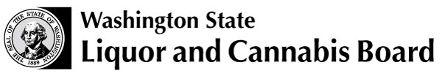 | Licensing and Regulation  1025 Union Ave SE  PO Box 43098  Olympia WA 98504-3098  Phone: 360 664-1600  Fax: 360 753-2710  www.lcb.wa.gov
 |  | License Number
 |  | Trade Name
 |  | UBI Number

BEER AND WINE RESTAURANT TASTING ROOM ACKNOWLEDGMENT

Acknowledgment Processing Information
Please complete and submit this form to the licensing investigator processing your application.
Incomplete forms cannot be processed.
You are advised to keep a copy of this form for your records.
If you have questions, please call Customer Service at 360-664-1600, option1, then 2.

Recent rule changes now allow Domestic Winery Additional Location Tasting Rooms to apply for and receive a beer and wine restaurant license. (WAC 314-24-161(4))

If the location is shared with multiple wineries not of the same entity, violations will be addressed per the requirements of RCW 66.24.170(4) which are:

“…if the board cannot connect a violation of RCW 66.44.200 or 66.44.270 to a single licensee, the board may hold all licensees operating the additional location jointly liable.”

Additionally no free samples are allowed in the restaurant portion of the premises.

Each of the multiple wineries must submit a copy of this form acknowledging that they are aware that they might be held jointly liable for any violations and that they cannot give out free samples in the restaurant area of the location.

I certify by my signature that I am aware of the above restrictions and will comply with them.

Print Name: |  |  | Date:
Signature: |  |  | Phone: | ( )–( )-( )
Print Title: |  |  | E-mail
(for example, sole proprietor, corporate officer,
partner, LLC manager or member.)

